Overview

Introduction | The RDC is has some BIG news to share. We want to introduce you to our revived, refreshed, and re-branded Building Improvement Grant “BIG” Program.

Purpose | The Town of McCordsville’s Building Improvement Grant Program is designed to stimulate investment and initiate aesthetic improvements to buildings in McCordsville. The program is administered by the Town’s Redevelopment Commission (RDC) whose members in collaboration with the Town Manager and Town staff will work directly with applicants during the grant application process. All completed applications will be reviewed by the McCordsville Redevelopment Commission before being approved for funding.

Funding | The RDC is funding up to $30,000 per year from the Broadway TIF.

Logo | 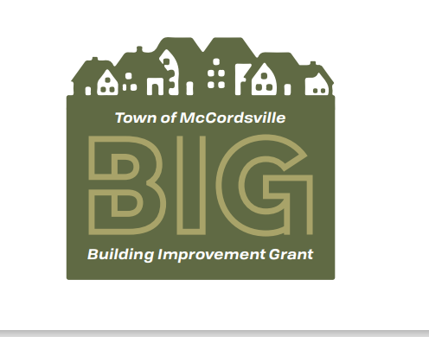

Eligibility Requirements | To participate in the Building Improvement Grant Program, an eligible property must:  - Be located within the corporate limits of the Town of McCordsville.  - (See Program Boundaries section for map)  - Have commercial activity as its primary purpose, including but not limited to traditional retail and  specialty shops, services, restaurants, and bars, live entertainment, cultural venues, galleries and professional offices including not-for-profits.  - Not be delinquent in property taxes, Town liens or fines or have any outstanding code compliance issues. This requirement applies to both property and applicant.

Boundary Map | 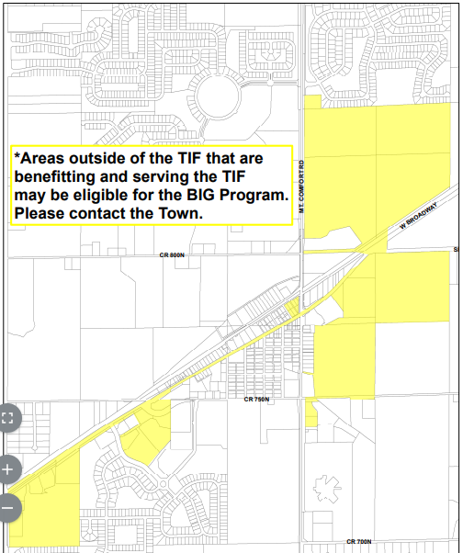

Grant Tiers | 2 Tiers for Grants  - Small to Mid-Sized Project Grant  - A 75% reimbursement of total approved actual project costs up to a maximum of $1000  - Large Project Grants  - A 50% reimbursement of total approved actual project costs up to a maximum of $5,000

Eligible Improvements and Expenses | Awnings - Canvas awnings without signage. Also includes canopies, marquees, and railings where historically and/or architecturally appropriate. May also include the removal of non-conforming or unused awnings and canopies.  Lighting - Restoration, replacement, or new construction of historically and/or architecturally sensitive decorative lighting fixtures for the exterior of the building.  Hardscapes - Hardscapes such as trellis work and fixtures permanently adhered to the façade of the building may be considered on a case by case basis if they are part of a larger design scheme.  Other Small Projects - Miscellaneous small projects that fall beneath the funding limit of $1000 may include window and door repair or replacement, exterior surface cleaning and painting, and small detail work.  Landscape – Landscape improvements which are permanent in nature (trees, bushes, etc.).  Infrastructure-Infrastructure improvements to the privately owned building and premises including but not limited to, repaving private parking lots, curb and sidewalk repairs, and pavement striping.  Doors and Windows– Repair, restoration, replacement and installation of doors and windows, frames, railings, sills, glazing or glass, including storefront display windows. Restoration or reconstruction of original store-front entrance, as well as original window openings, is encouraged.  Exterior Wall Finishes – Cleaning, repairing, or repainting building exterior surfaces, including brick, stone, wood, cast iron, tile, stucco or other similar exterior finishes and decorative treatments. All exterior wall finishes and improvements will be compatible to the architectural style of the building, and color schemes shall accent the building and harmonize with adjacent buildings.  Cornices and Decorative Detailing – Repairing or replacing cornices and other decorative detailing.  Site Improvements - Including decorative fencing and improved pedestrian amenities such as benches.  Structural Reinforcement – As necessary to rehabilitate the façade(s) and/or roof and chimneys. Costs associated with structural reinforcement may not exceed 25% of the total project cost.  Other Repairs - Repairs and other exterior improvements that may improve the aesthetic quality and historic integrity of the building.

Ineligible Expenses | Inappropriate Materials and Treatments - Including but not limited to the installation of aluminum or vinyl siding and the use of sandblasting.  Interior Improvements - Including restoration or rehabilitation work, interior window coverings, furnishings, equipment, and interior window displays.  Electrical Work - Except as related to exterior lighting.  Security Systems  Personal Property - The purchase and installation of furnishings, equipment, or other personal property which does not transfer ownership as part of the real estate.  Permits & Fees - Any local and/or state permitting costs or fees.  Work Prior to Grant Approval-Any work in progress or completed prior to grant approval.

Effective Date | Applications accepted beginning January 1, 2022

Next Steps | Develop and finalize a marketing and communication strategy.  Update the McCordsville Town website with Program information.

